Exercise 24: Raster Analysis using ModelBuilder
This exercise will describe how to create a model using ArcGIS ModelBuilder. Specifically, you will create a model using raster analysis techniques and input raster data. The goal will be to produce a model that predicts the habitat of the Yellowed-Bellied Salamander (Imado thisupocus). Within the study area extent, this salamander can be found in deciduous forested landscapes above 800 meters. It only occupies core forested areas (core areas >250 acres), and on the following landforms: steep slopes, slope crests, upper slopes, flat summits, sideslopes, and coves.

Topics covered in this exercise include:
- Create a ModelBuilder tool using raster analysis tools and techniques
- Use reclassify and raster calculator operations
- Change environment settings
- Summarize raster model output within polygon features
- Perform table joins

Step 1. Open a Map Project
First, we need to download and open the Exercise_10.aprx file.
Click on the Exercise_10.aprx file within the uncompressed folder directly to launch ArcGIS Pro.
This project contains a single map that contains six data layers.
Study_Boundary_Dissolved: polygon extent of study area boundary defined relative to watershed extents
watersheds: polygon watershed extents that are within the study area
nlcd_2011: categorical raster grid of land cover from the 2011 National Land Cover Database (NLCD)
fragment: categorical raster grid of forest fragmentation estimates (This grid was created using the Landscape Fragmentation Tool made available by the University of Connecticut: http://clear.uconn.edu/tools/lft/lft2/index.htm)
elu: categorical raster grid of ecological land units (ELUs)
elevation: digital elevation model (DEM) raster grid in meters
Note: All of the raster grids are 30 by 30 meter resolution.
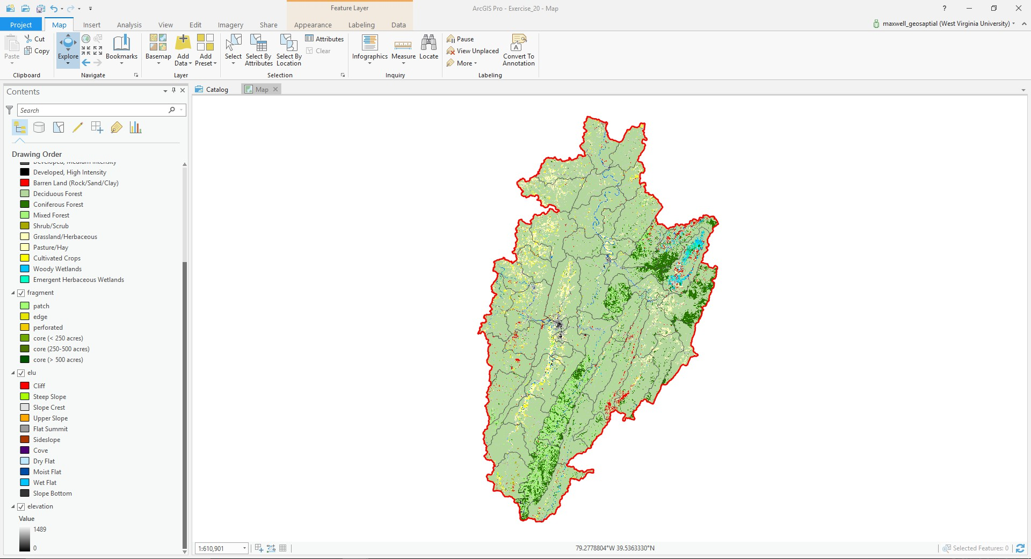

Note: The symbology for these raster grids were applied using a layer file. Here is a brief explanation of how layer files can be created and used. Once the layer has been symbolized, this symbology can be saved as a layer file. A layer file is not a copy of the spatial data; instead, it simply saves the symbology settings. To save a layer file, right-click on a layer in the Contents Pane then select Save as Layer File. Note that
older layer files can generally be used in newer versions of the software. However, newer layer files cannot be used in older versions of the software. Once a layer file has been saved, it can be used to symbolize a new layer. In the Symbology Pane, layer files can be imported. So, layer files can be used to save and apply symbology.

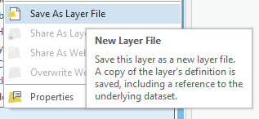
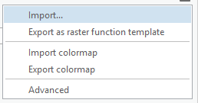

Step 2. Create a New Toolbox
Before you begin the analysis, you will need to create a new toolbox in which to save your model. You will do so using ArcCatalog.
- In ArcGIS Pro, navigate to the View Tab then select Catalog View. This will open the Catalog View if it is not already open.
- In the Catalog View, double-click on Toolboxes. This will open a list of available toolboxes.
- Right-click in the toolbox space within the Catalog View then select New Toolbox. Provide a name (Exercise10) to save the new toolbox.
- Finally you will see a new toolbox named with ‘Exercise10’
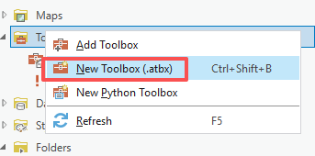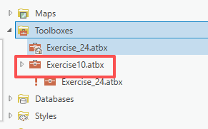
Note: Each project has a default toolbox associated with it. You can use this toolbox. Here, we are having you create a new toolbox so that you know how to do so. Tools, such as models, must be saved inside of toolboxes.

Step 3. Creating the Model

- Return to ArcGIS Pro. You will not need to use ArcCatalog again in this lab, so you can close it if you’d like.

Navigate to the Analysis Tab then select ModelBuilder under the Geoprocessing area. This will open the ModelBuilder window.

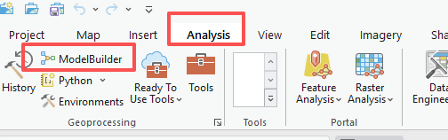
- In the ModelBuilder Tab, click on the Save As button.
- Navigate to the toolbox you just created and save the model in the toolbox as species_model.
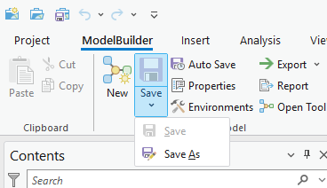
In this lab we will define the required habitat as deciduous forest land cover at elevations above 800 meters in core forested areas (core areas >250 acres) and on the following landforms: steep slopes, slope crests, upper slopes, flat summits, sideslopes, and coves. To create this model you will need to complete the following analysis tasks:
- Use the Raster Calculator Tool to create a binary land cover classification in which deciduous forests are recoded as 1 and all other classes are coded as 0.
- Use Raster Calculator Tool to create a binary elevation classification in which all elevations above 800 meters are coded as 1 and all elevation less than 800 meters are coded as 0.
- Use the Reclassify Tool to recode all core forests (core areas
>250 acres) as 1 and all other forests as 0.
- Use the Reclassify Tool to code steep slopes, slope crests, upper slopes, flat summits, sideslopes, and coves as 1 and all other landforms at 0.
- Multiply all the resulting binary grids to find all grid cells in the study area that meet all the criteria.

This section of the exercise will guide you in creating the model. Once your model is complete, it should look like the model presented below.

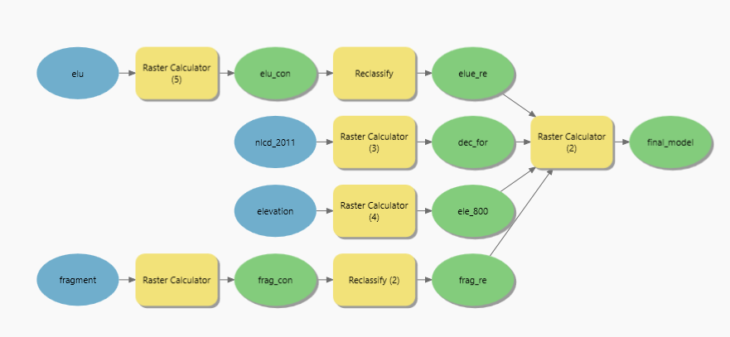

First, change the environment settings for the model.
  - In the ModelBuilder Tab and in the Model area, select the Environments button.
  - Set the Current Workspace and the Scratch Workspace to the Exercise_10.gdb geodatabase that is in the Exercise_10 folder.
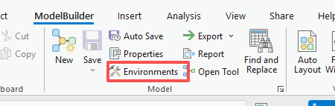
  - Set the Output Coordinate System to be the same as Current Map [Map] (should be NAD 1983 UTM Zone 17 North).
  - Set the Processing Extent to be the same as the
Study_Boundary_Dissolved layer.
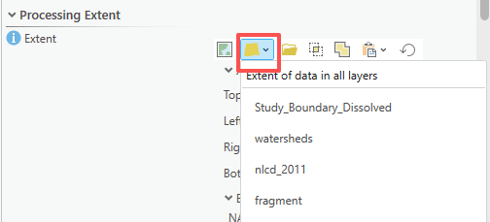
  - Set the Snap Raster to the elevation layer.
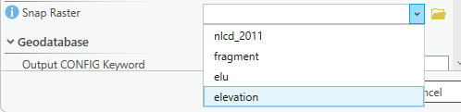
  - Set the Cell Size to be the same as the elevation layer (should be 30).
  - Set the mask to the Study_Boundary_Dissolved layer.
  - Click OK to save these environment settings.

Note: Environment settings changed within ModelBuilder are only honored by operations performed within the model, not by all operations performed within the project.

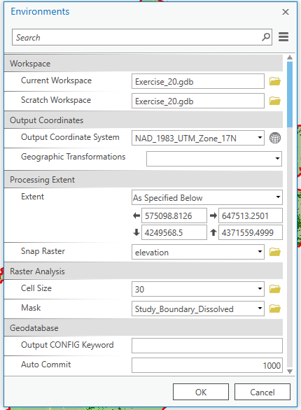

Add the input layers (nlcd_2011, elevation, fragment, elu) to the model by dragging them from the Contents Pane to the model area.

There are many options for adding tools to the model. Here, you will use ArcToolbox.
  - Left-click on the Tools button under ModelBuilder. This will open the Geoprocessing Pane. In the Geoprocessing Pane, click on Toolboxes to view ArcToolbox. Tools can be added by dragging them from ArcToolbox to the model area.
  - Add the following tools to the model.

- Raster Calculator Tool (You will need 5) (This can be found in the Map Algebra subtoolbox of the Spatial Analyst Toolbox.)
- Reclassify Tool (You will need 2) (This can be found in the Extract subtoolbox of the Spatial Analyst Toolbox.)

You will now need to specify the settings for each tool. The outputs will automatically save to the Exercise_10.gdb geodatabase, as this was defined as the working directory. To edit the settings for each tool, click on each tool to open up the wizard. Once you have specified the desired settings, click OK to accept the changes. Note that links between inputs and tools and tools and outputs will be created as you change the settings.
  - Extract deciduous forest from nlcd_2011 using Raster Calculator Tool
    - Use the following raster calculator expression: "%nlcd_2011%" ==41
    - Output Raster = dec_for
  - Extract elevations above 800 meters from elevation using Raster Calculator Tool
    - Use the following raster calculator expression: "%elevation%"
>800
    - Output Raster = ele_800
  - Extract core forested areas (core areas >250 acres) from fragment
using Raster Calculator
    - Map Algebra expression: Convert class 6 to class 5 first, otherwise the tool will always lock class 6 in the reclassify Tool.
      - Con("%fragment%" == 6, 5, "%fragment%")
    - Output raster: frag_con
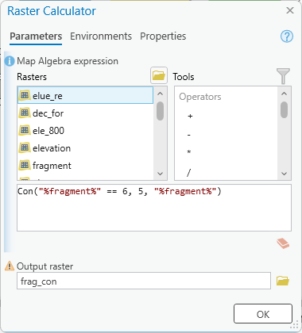
using Reclassify Tool
    - Input Raster = frag_con
    - Reclass Field = “VALUE”
    - Use the table below to reclassify the raster.
    - Output Raster = frag_re
In this process, class 6 has already changed to class 5, so it doesn’t matter what value you assign to class 6.

Old Values | New Values
1 | 0
2 | 0
3 | 0
4 | 0
5 | 1
6 | 2
NODATA | NODATA

  - Extract landforms from elu
Using raster calculator
In Map Algebra expression, if elu is class 33, change the value to class 0
Con("%elu%" == 33, 0, "%elu%")
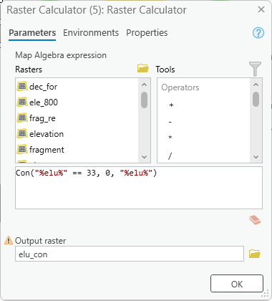
Output raster: elu_con

using Reclassify Tool
    - Input Raster = elu_con
    - Reclass Field = “VALUE”
    - Use the table below to reclassify the raster.
    - Output Raster = elue_re
In the Reclassify Tool, the class 33 has already changed to class 0 in the Raster calculator tool, so it doesn’t matter what value you assign to class 3.

Old Values | New Values
10 | 0
11 | 1
12 | 1
13 | 1
14 | 1
20 | 1
21 | 1
30 | 0
31 | 0
32 | 0
33 | 11
NODATA | NODATA

  - Multiply results to obtain the final model using Raster Calculator Tool
    - Use the following raster calculator expression: "%dec_for%" * "%ele_800%" * "%frag_re%" * "%elu_re%"
    - Output Raster = final_model

You should now have a completed model that looks like the one shown above.
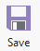
  - Save your model by clicking on the Save button in the Model area of the ModelBuilder Tab.

Note: You can make your model graphic a little neater by using the Auto Layout Button. This can be used to make the graphic more orderly. Blue indicates inputs, yellow indicates tools or processes, and green indicates outputs.

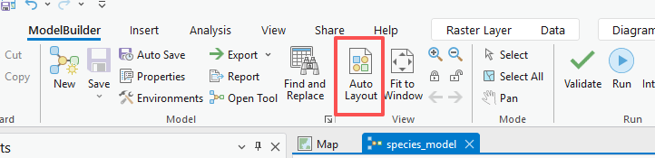

Step 4. Execute the Model
Now that you have a complete model, it can be executed. Before you execute the model, it is generally a good idea to validate the model.

  - Click on the Validate Tool in the Run area of the ModelBuilder Tab to validate the model. If no issues are flagged, no issues were detected.
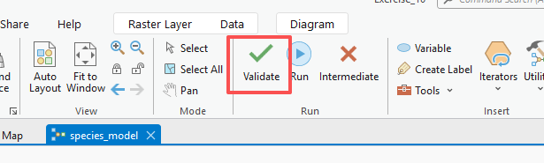
  - You can now run your model. Do this by clicking the Run Button in the Run area of the ModelBuilder Tab.
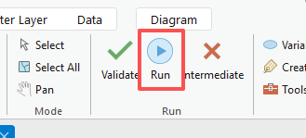
  - Once the model executes, no layers will be added to your map. You will need to add the final_model output to the
map to answer the questions below. To do this, right-click on the output model graphic then select Add to Display. Feel free to add all of the other intermediate outputs.
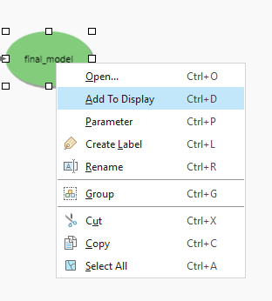

Deliverable 1: Provide a screenshot of your final_model. (10 pts)
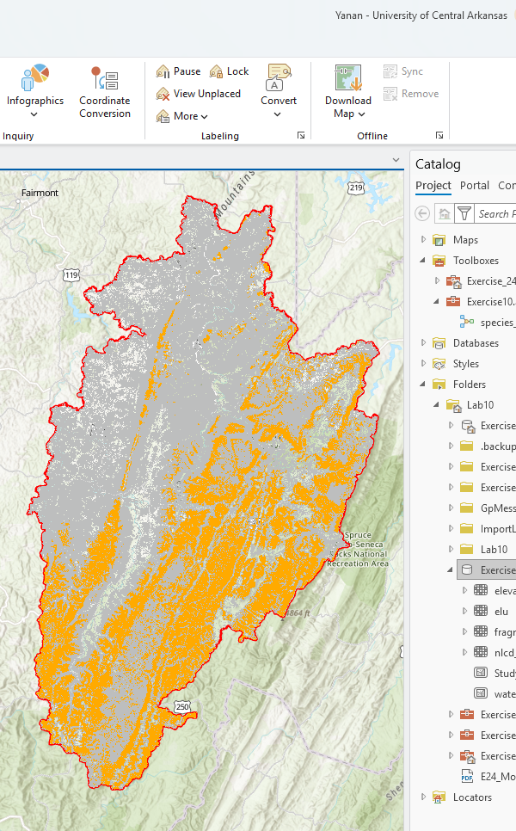

Use the results (final_model) to answer the following questions. Note that cells coded as 1 met all of your criteria whereas cells coded as 0 did not meet all of your criteria.
Question 1. How many pixels were found to be suitable habitat? (10 points)
Answer: 1602975
Question 2. What is the cell size of the model? (10 Points)
30 * 30
Question 3. What is the area of suitable habitat in square meters? (10 Points) (hint: check the Linear Unit in Spatial reference of final_model)
30*30*1602975
Question 4. What is the area of suitable habitat in hectares? (10 Points) (hint: 1 square meter = 0.0001 hectares)
30*30*1602975*0.0001
Question 5. What is the area of suitable habitat in acres? (10 Points) (hint: 1 square meter = 0.000247105 acres)
30*30*1602975*0.000247105

